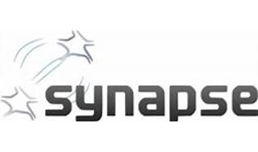



Explore

Certainly! **Apache Synapse** is a lightweight and high-performance **Enterprise Service Bus (ESB)** that provides exceptional support for XML, Web Services, and REST. [It’s powered by a fast and asynchronous mediation engine1](https://synapse.apache.org/). Here are some free resources to learn more about Apache Synapse:

1. [**Quick Start Guide**](https://synapse.apache.org/userguide/quick_start.html): This tutorial covers fundamental usage scenarios, including message mediation and service mediation. [It’s a great starting point for understanding Synapse](https://synapse.apache.org/)[2](https://synapse.apache.org/userguide/quick_start.html).
2. [**Azure Synapse Analytics**](https://learn.microsoft.com/en-us/azure/synapse-analytics/get-started): Explore Azure Synapse Analytics, which includes Apache Spark integration[3](https://learn.microsoft.com/en-us/azure/synapse-analytics/get-started).
3. [**Data Engineering with MS Azure Synapse Apache Spark Pools**](https://www.coursera.org/learn/data-engineering-with-ms-azure-synapse-apache-spark-pools): A Coursera course focusing on optimizing Apache Spark jobs in Synapse Analytics[4](https://www.coursera.org/learn/data-engineering-with-ms-azure-synapse-apache-spark-pools).
4. [**Top Free Resources for Learning PySpark**](https://medium.com/illumination/top-free-resources-for-learning-pyspark-in-self-paced-learning-9dfc26748eea): While this resource is primarily about PySpark, it can provide insights into Spark-related concepts applicable to Synapse[5](https://medium.com/illumination/top-free-resources-for-learning-pyspark-in-self-paced-learning-9dfc26748eea).
5. [**Apache Synapse Documentation**](https://synapse.apache.org/docs_index.html): Explore the official documentation for in-depth information on configuration, features, and best practices[6](https://synapse.apache.org/docs_index.html).

Happy learning! 🚀🌟